结构可靠度分析的均匀设计响应面法(宋二加粗）

***¹ ***¹ ***¹（楷四）

(***大学**学院，城市 邮政编码) （楷五）
摘要：均匀设计和正交设计在试验次数相近的情况下，前者所选试验点均匀性更好，...。（宋小五）
关键词：结构可靠度；均匀设计；响应面法；混合模拟法；门式框架（宋小五）
中图分类号：TU311.4 文献标识码：A（黑小五加粗）
Uniform design response surface method for structural reliability analysis
(times new roman四号加粗)
Lu *** ¹ Jia M*** ¹ Li G***¹ (times new roman五号)
(School of Civil Engineering, ***University, City Zip code , China)
Abstract: The chosen experiment points of a uniform design (UD) is generally more uniform and representative than an orthogonal design (OD), even though in the case that the trial numbers of the two experiment design methods are near. In this paper, a new numerical simulation method for structural reliability analyses is firstly proposed, which incorporates a uniform design into the conventional response surface method, herein named as uniform design response surface method (UDRSM). And then, a hybrid simulation method (HSM) combing Monte Carlo Simulation (MCS) and UDRSM is put forward. The simulation process of the new method includes the following steps: (1) choosing testing points, (2) constructing response surface equation, and (3) calculating structural reliability. The two new methods are all implemented in ANSYS by using the deterministic finite element method. A portal frame is taken as a numerical example. The accuracy and efficiency of the new methods are demonstrated by contrasting the new proposed method with the classical numerical simulation methods including Monte Carlo simulation (MCS) and orthogonal design response surface method (ODRSM). It is shown that the limit state function of UDRSM is more accurate than other methods, and that HSM is more efficient than others. (times new roman小五)
Keywords : structural reliability; uniform design; response surface method; hybrid simulation method; portal frame

引 言（宋小四加粗）
结构可靠度数值模拟方法主要有蒙特卡罗法，响应面法以及二者结合的混合模拟法等^{[1―5]}。..。(宋五号)
1 均匀设计方法（宋五加粗）
1.1均匀设计的理论基础（宋五加粗）
1.1.1多维积分的抽样计算（宋五）
均匀设计就是只考虑试验点在试验范围内均匀分布的一种试验设计方法，是以伪蒙特卡罗法为基础的数值积分。均匀设计是在特定的稳健回归模型下达到最优，其回归模型为：
(1)
式中：的试验区域为；g是某个已知函数类。
(1)…………。
(2)…………。
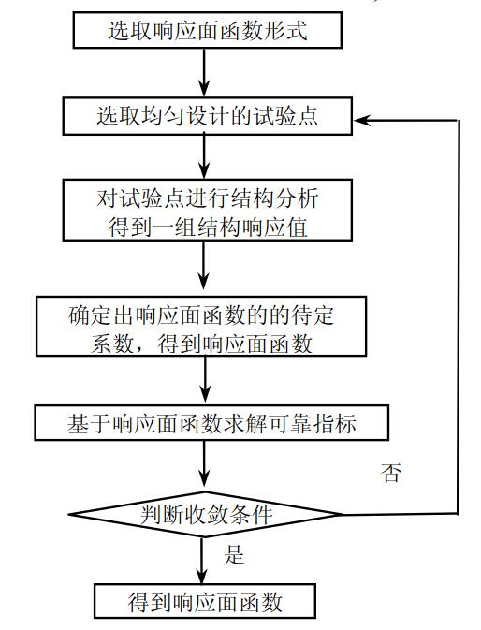

图1 均匀设计响应面法流程图（黑小五加粗）
Fig.1 Flow chart of UDRSM (times new roman小五加粗)

表1 随机变量统计特征（黑小五加粗，宋六号）
Table1 Statistical characters of random variables (times new roman小五加粗)
随机变量 | 均值 | 标准差 | 分布类型
 | 0.36 | 0.036 | 对数正态 | 0.08333
 | 0.18 | 0.018 | 对数正态 | 0.16670
 | 20 | 5.0 | 极值I型 | -

参考文献（黑小五加粗、time new roman小五、宋小五）
[1] Andrzej S N, Kevin R C. Reliability of structures [M]. America: The McGraw-Hill Companies Inc, 2000.
[2] Robert E M. Structural reliability analysis and prediction [M]. 2nd ed. Australia: John Wiley & Sons Ltd, 1999.
[3] 金伟良. 结构可靠度数值模拟新方法[J]. 建筑结构学报, 1996, 17(3): 63―72.
[4] 赵国藩, 金伟良. 结构可靠度理论[M]. 北京: 中国建筑工业出版社, 2001.
[5] 赵国藩. 结构可靠性理论与应用[M]. 大连: 大连理工大学出版社, 1996.

基金项目：xx基金项目资助（90715021）、xx基金项目资助（50978080）和xx基金项目资助（50678057） 作者简介：姓名，学历，职称 收稿日期：2018-05-06

